Cluster Systems
# Source: Chatgpt (GPT-5-Mini) at [1/16/2026]
A Cluster System is a type of distributed system in which multiple computers (nodes) are connected together and work closely as a single system to achieve high performance, high availability, or load balancing.
All nodes in a cluster are usually located in the same data center and connected by a high-speed local network.

Definition
# Source: Chatgpt (GPT-5-Mini) at [1/16/2026]
A Cluster System:
- Consists of multiple independent computers (nodes)
- Appears to users as one single system
- Shares workload among nodes
- Is tightly coupled

Architecture Diagram
# Source: Chatgpt (GPT-5-Mini) at [1/16/2026]
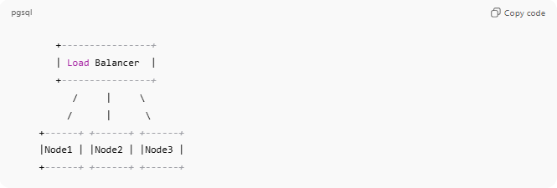
+----------------+
| Load Balancer |
+----------------+
/ | \
/ | \
+------+ +------+ +------+
|Node1 | |Node2 | |Node3 |
+------+ +------+ +------+

How Cluster Systems Work
# Source: Chatgpt (GPT-5-Mini) at [1/16/2026]
- Tasks are divided into smaller jobs
- Jobs are distributed among cluster nodes
- Nodes process jobs in parallel
- Results are combined and returned

Types of Cluster Systems
# Source: Chatgpt (GPT-5-Mini) at [1/16/2026]
a) High-Performance Clusters (HPC)
- Used for heavy computations
- Example: Weather forecasting, scientific simulations
b) Load-Balancing Clusters
- Distribute client requests
- Example: Web server clusters
c) High-Availability (HA) Clusters
- Provide failover when a node fails
- Example: Banking systems

Key Characteristics
# Source: Chatgpt (GPT-5-Mini) at [1/16/2026]
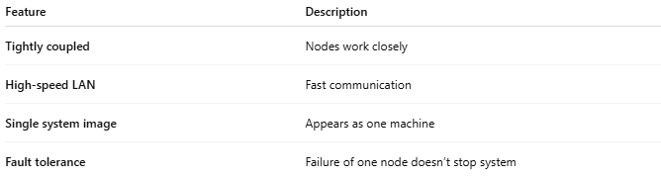
Feature | Description
Tightly coupled | Nodes work closely
High-speed LAN | Fast communication
Single system image | Appears as one machine
Fault tolerance | Failure of one node doesn’t stop system

Real-World Examples
# Source: Chatgpt (GPT-5-Mini) at [1/16/2026]
- Google search servers
- Supercomputers
- Financial trading systems
- Database clusters (Oracle RAC)

Advantages
# Source: Chatgpt (GPT-5-Mini) at [1/16/2026]
- High performance through parallel processing
- High availability
- Easy scalability (add more nodes)
- Cost-effective compared to supercomputers

Disadvantages
# Source: Chatgpt (GPT-5-Mini) at [1/16/2026]
- Complex setup and management
- Requires specialized hardware/software
- Not suitable for geographically distributed systems

Cluster vs Grid Systems
# Source: Chatgpt (GPT-5-Mini) at [1/16/2026]
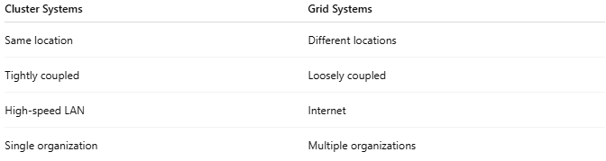
Cluster Systems | Grid Systems
Same location | Different locations
Tightly coupled | Loosely coupled
High-speed LAN | Internet
Single organization | Multiple organizations

Simple Analogy
# Source: Chatgpt (GPT-5-Mini) at [1/16/2026]
- Cluster System: A team in the same office working together
- Grid System: Teams working remotely across countries

